**Name:حسن شريف حسن عبده**

**B.N: 296**

**Date: 14/7/2020**

**Topic:** **Programming Languages**

**e-mail: hasan195327@feng.bu.edu.eg**

**Github link:**

**Github page:**

**Application briaf:**

**What is the Programming:** Programming is the composition of a lot of orders, or what is known as the code, and these orders are what establish what is known as the program, it is the thing that drives him. A PC or electronic gadget interprets this request for execution.

**Programming language:** : In the programming procedure, exceptional languages known as Programming languages are utilized. These languages ​​carry vocabulary in addition to specific rules to guide the computer system to carry out specific tasks. Each programming language contains a set of Keywords in addition to a specific writing method called "Syntax", which specifies how program commands are organized.

**Screenshots:**

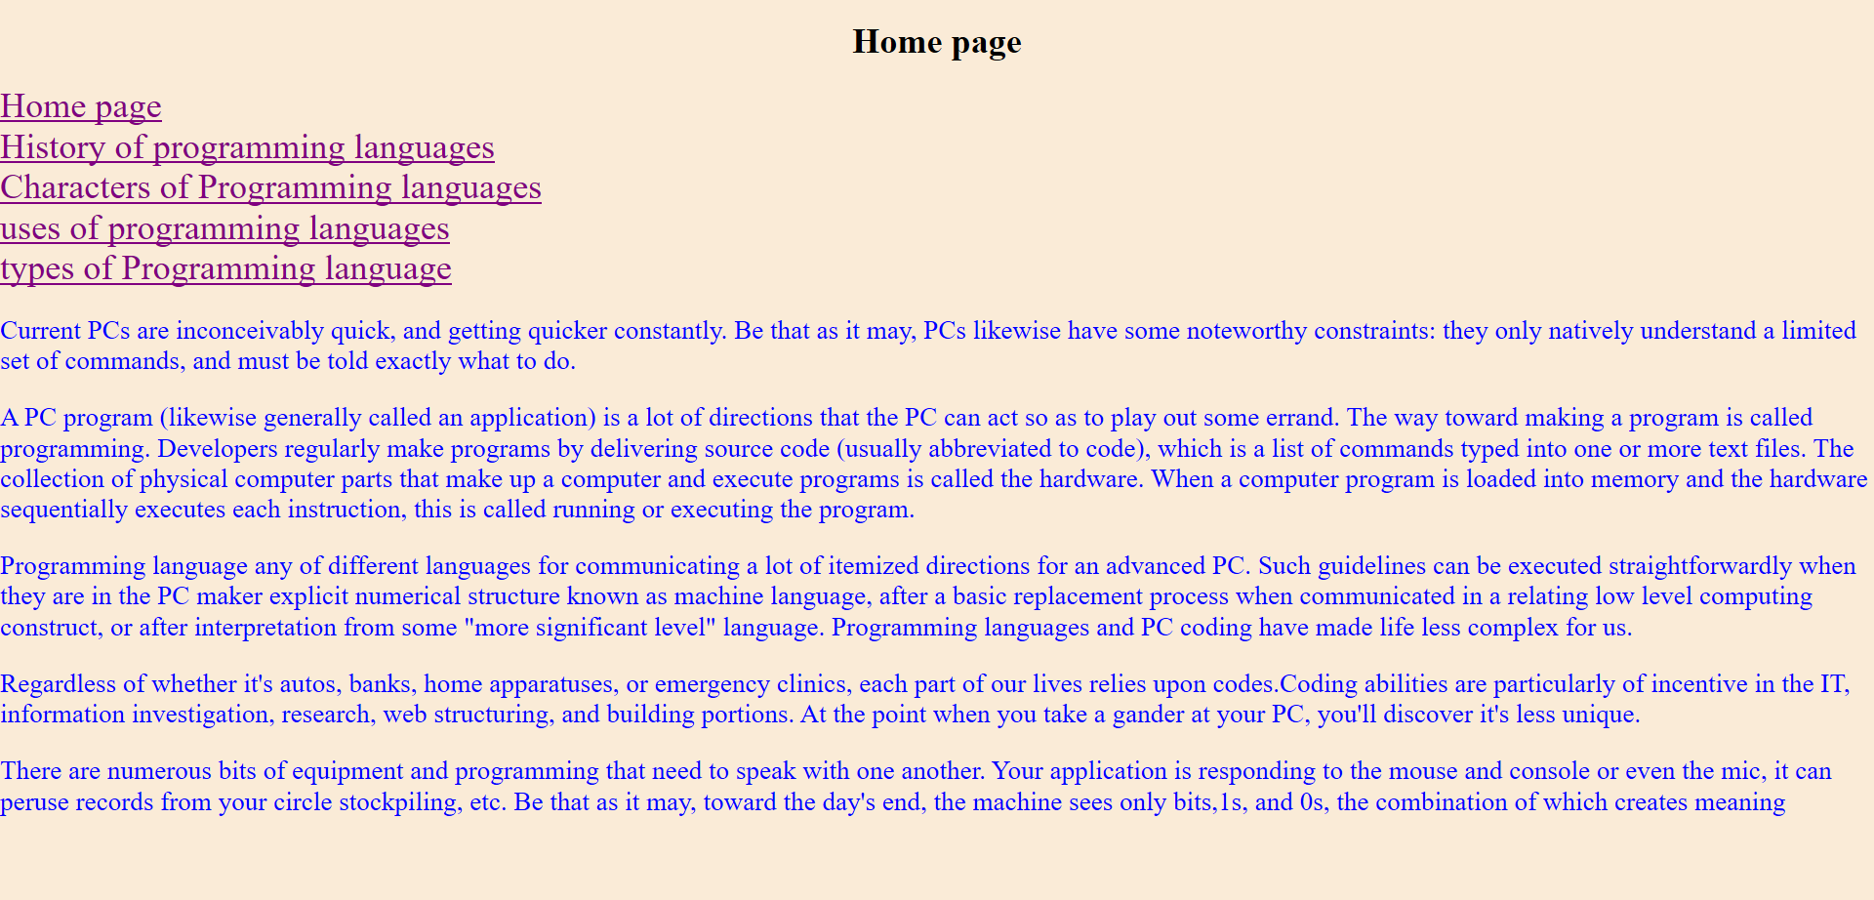**The website:**

**The second page**

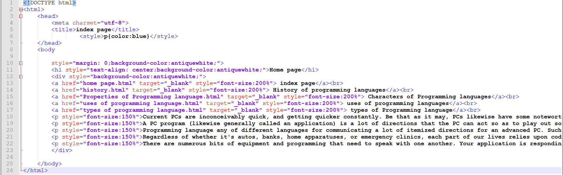**The code of website:**

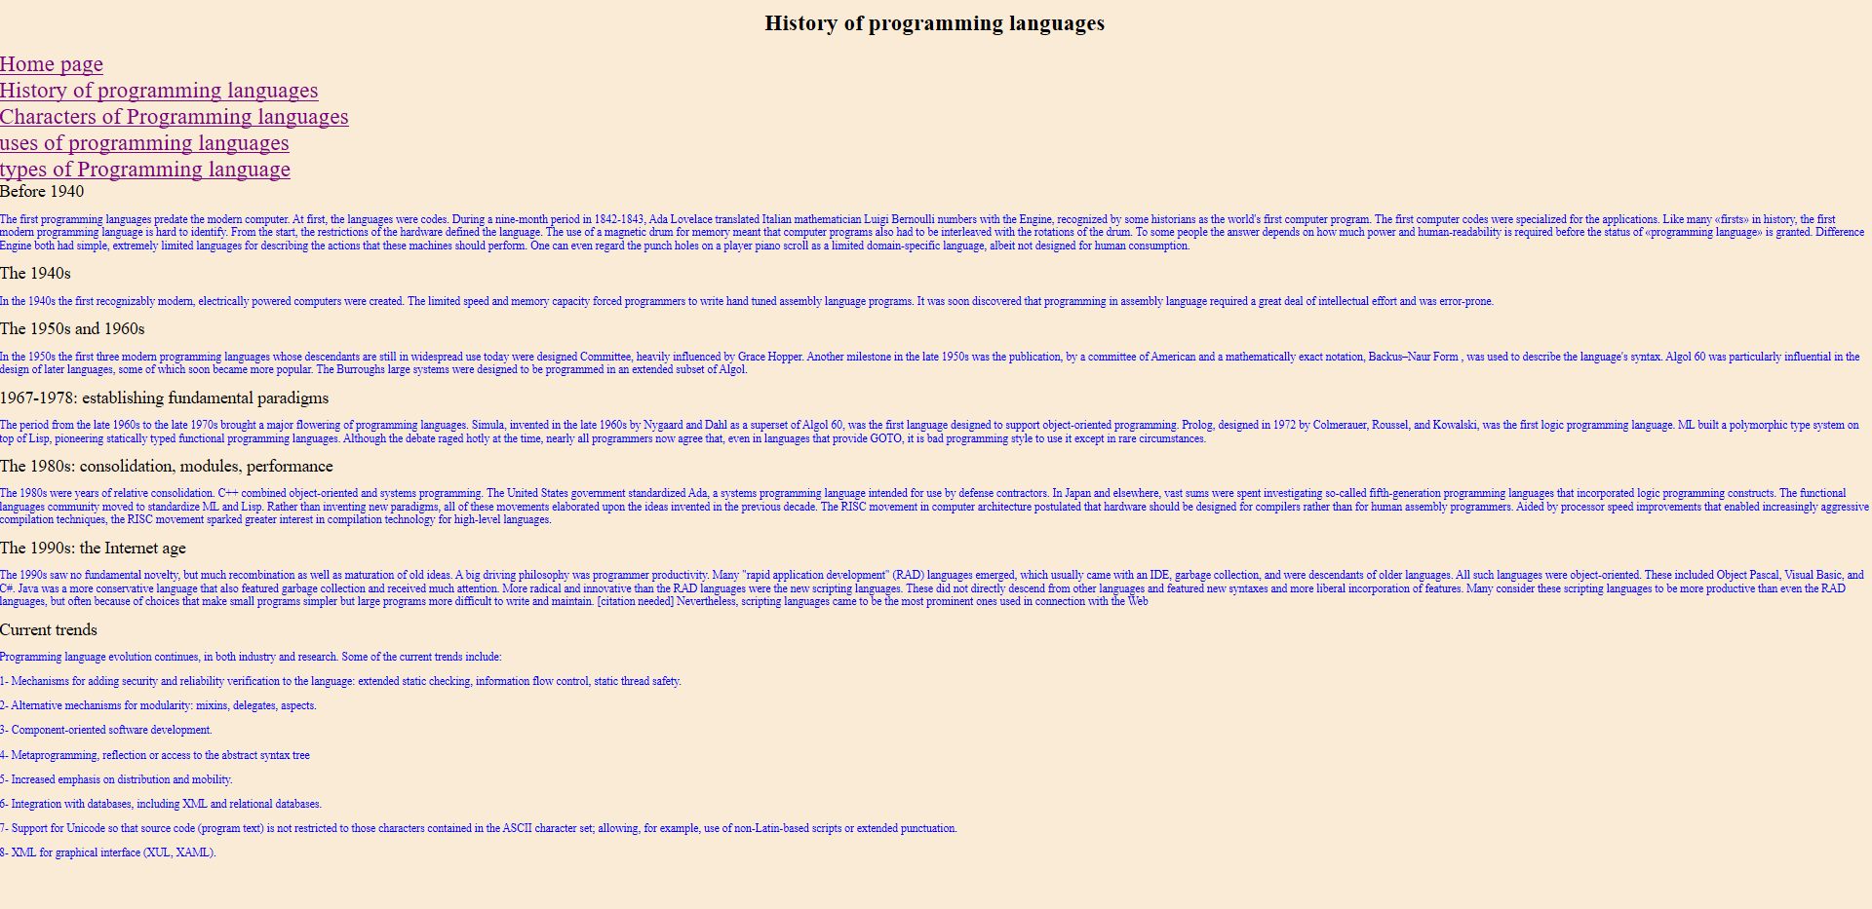**The website:**

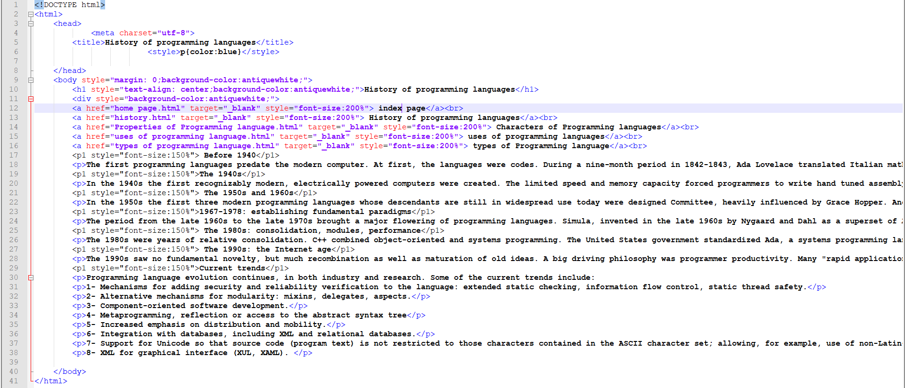**The code of website:**

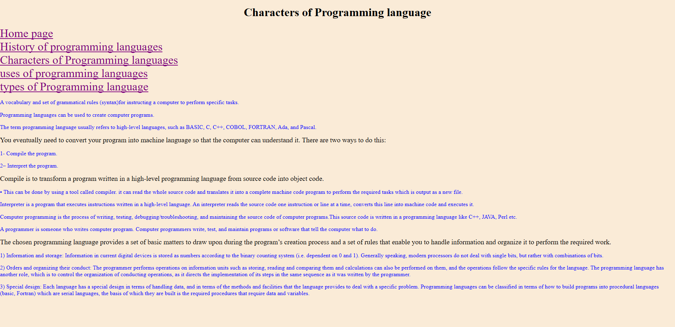**The website:**

**Codes of second page**

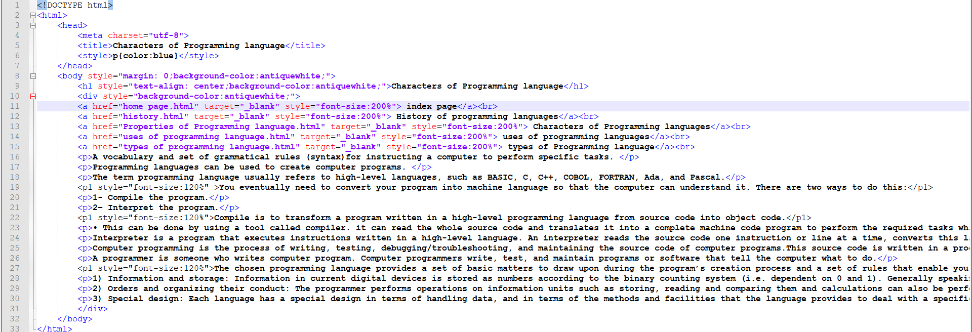**The code of website:**

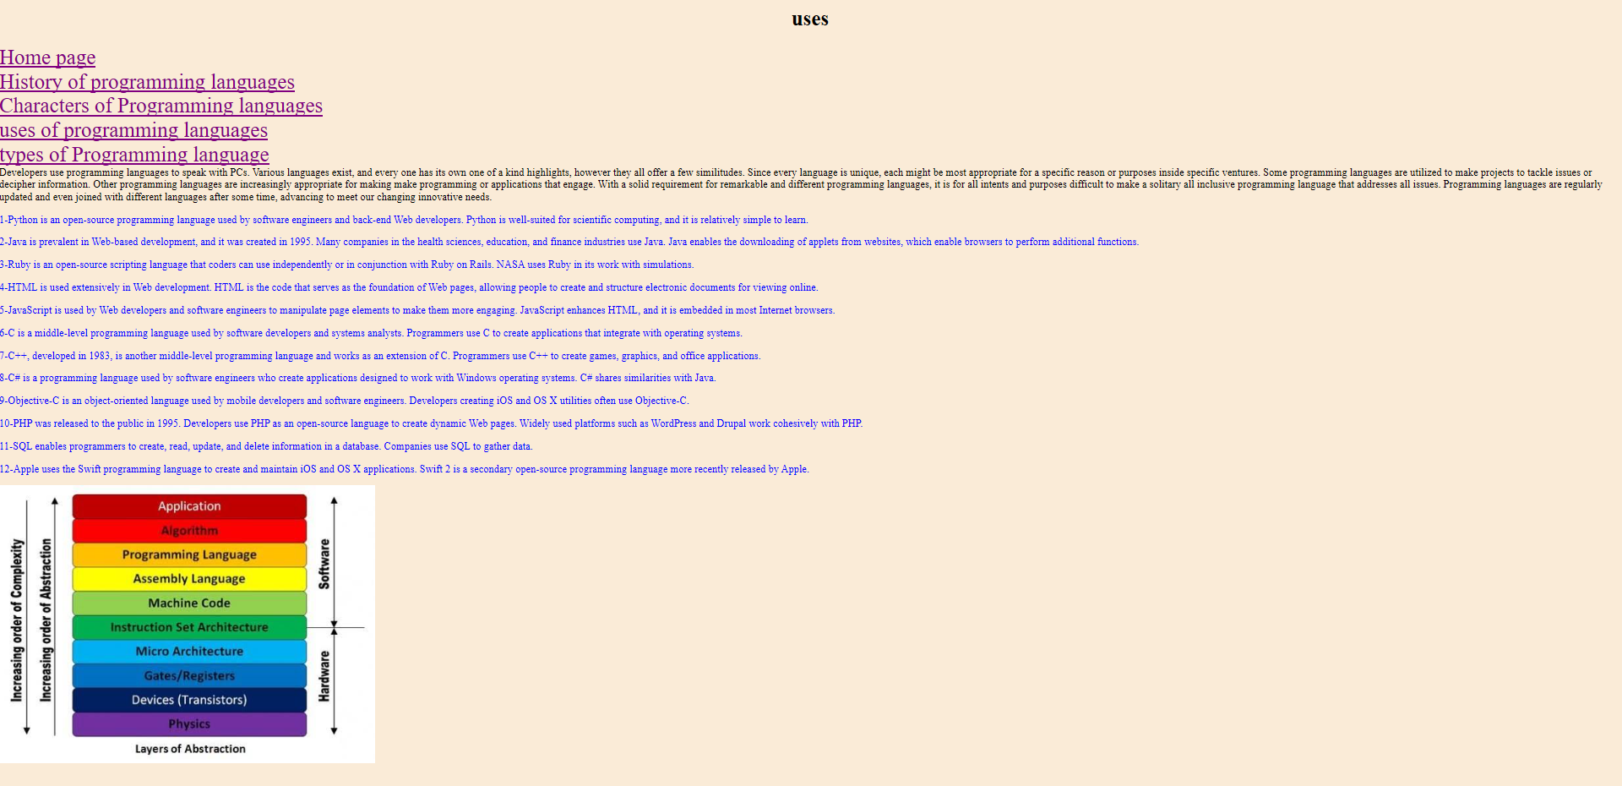**The website:**

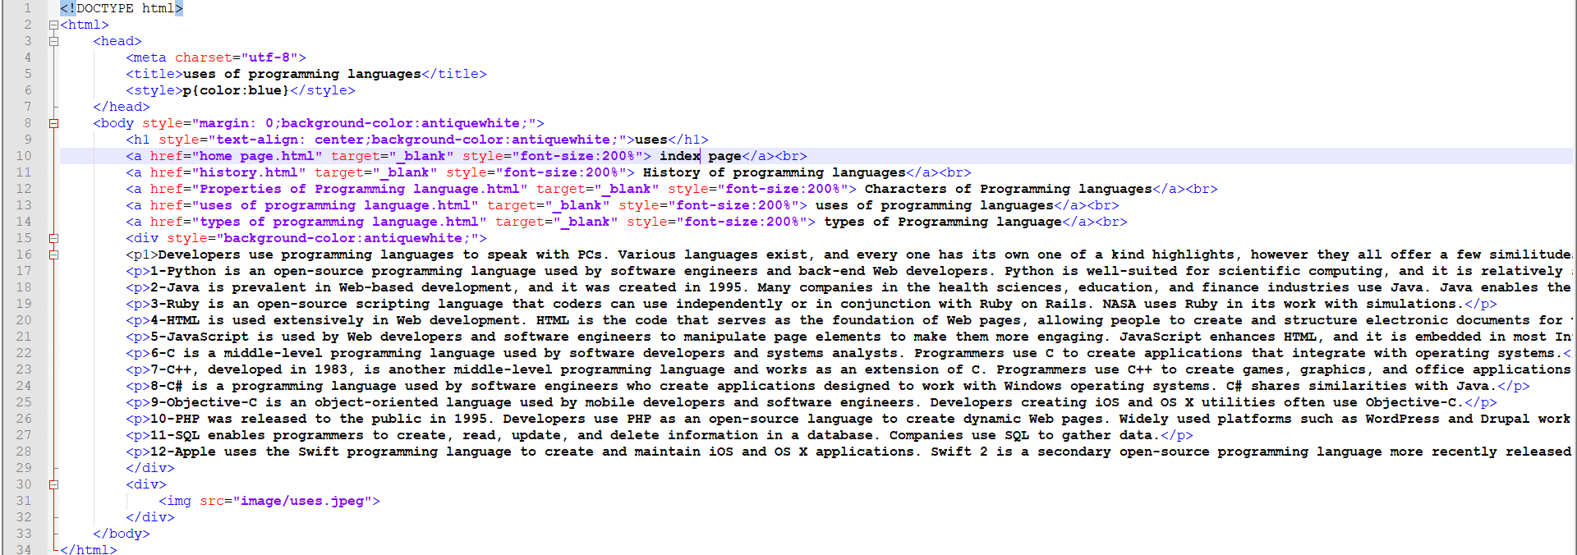**The code of website:**

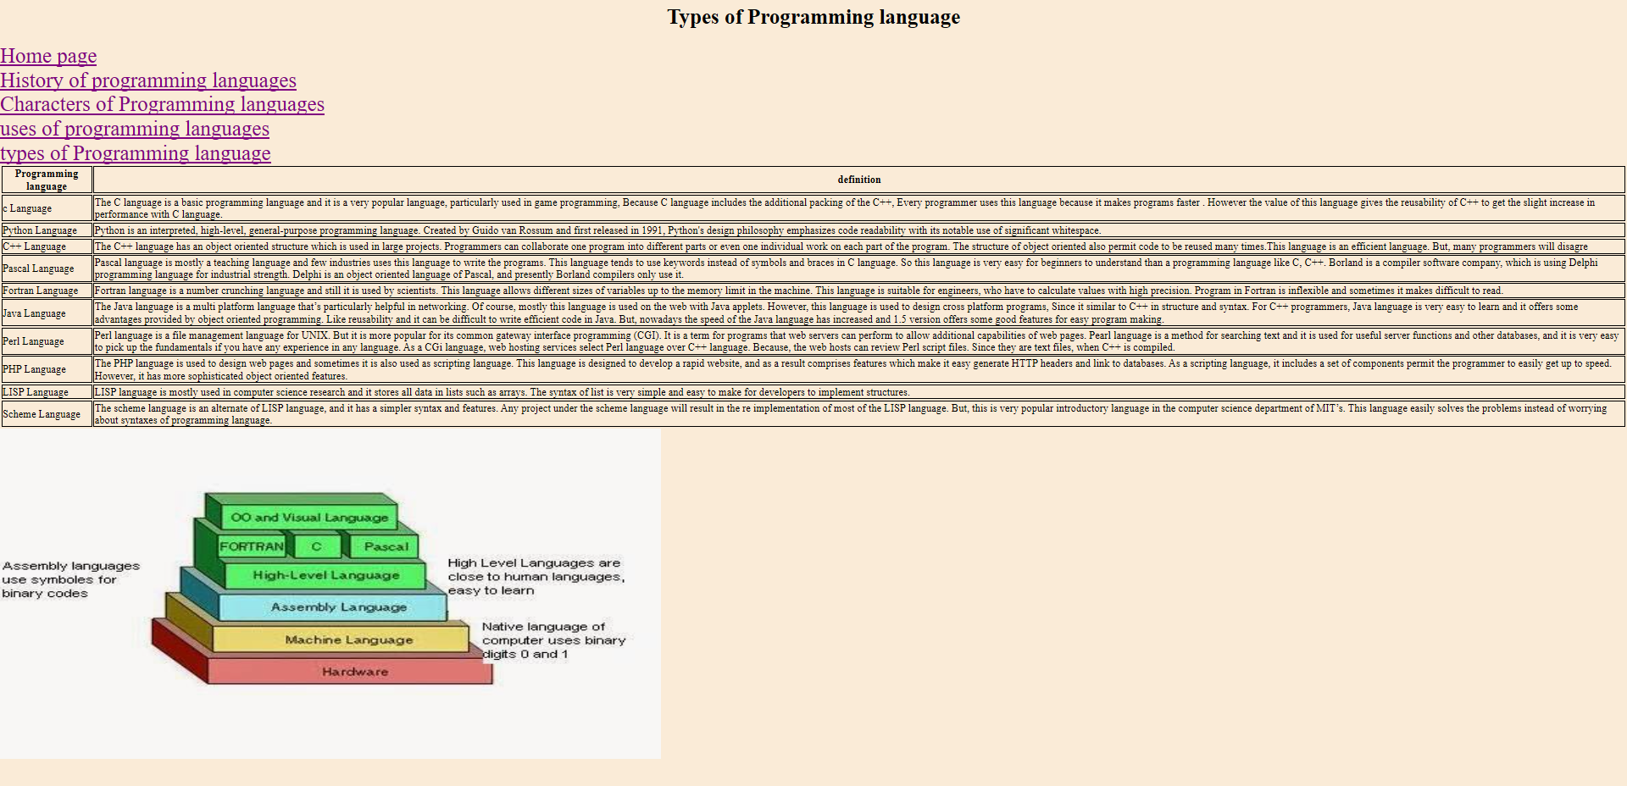**The website:**

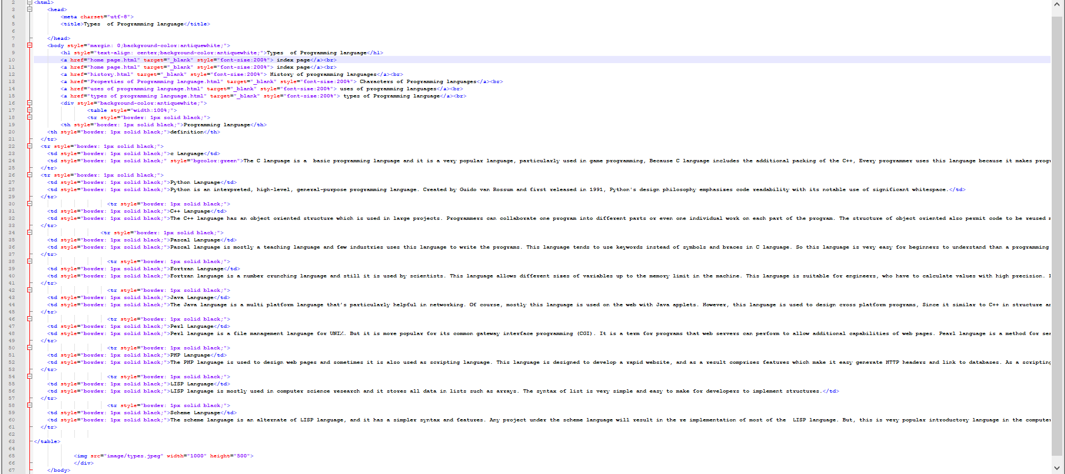**The code of website:**